Online Internship Management System
SUBMITTED BY:
STUDENT NAME | ROLL NO
ABDUL BASIT | BSAI51S25R0
MUHAMMAD LUQMAN SAHI | BSAI51S25R013
MUHAMMAD ABDULLAH | BSAI51S25R035

CLASS: BSAI 3rd SEMESTER REGULAR
SUBMITTED TO: DR . MUHAMMAD ILYAS

Department of Computer Science

Database Design

Database Design Overview
The database for the Online Internship Management System is designed using the relational model. It consists of fourteen main tables that store information about users, students, companies, mentors, internships, applications, interviews, internship assignments, progress reports, certificates, skills, resumes, and feedback. Each table is connected to other tables using primary keys and foreign keys, which keep the data organized, consistent, and free from unnecessary repetition.
The design follows a simple rule: every piece of information is stored only once, in the table where it logically belongs, and tables are linked together using relationships so that related data can always be retrieved together when needed.

Entity Relationship Diagram (ERD)
The Entity Relationship Diagram (ERD) below shows all the entities (tables) of the system, their attributes, and how they are connected to one another. Primary Keys (PK) are underlined and shown at the top of each entity box, while Foreign Keys (FK) are shown below them.
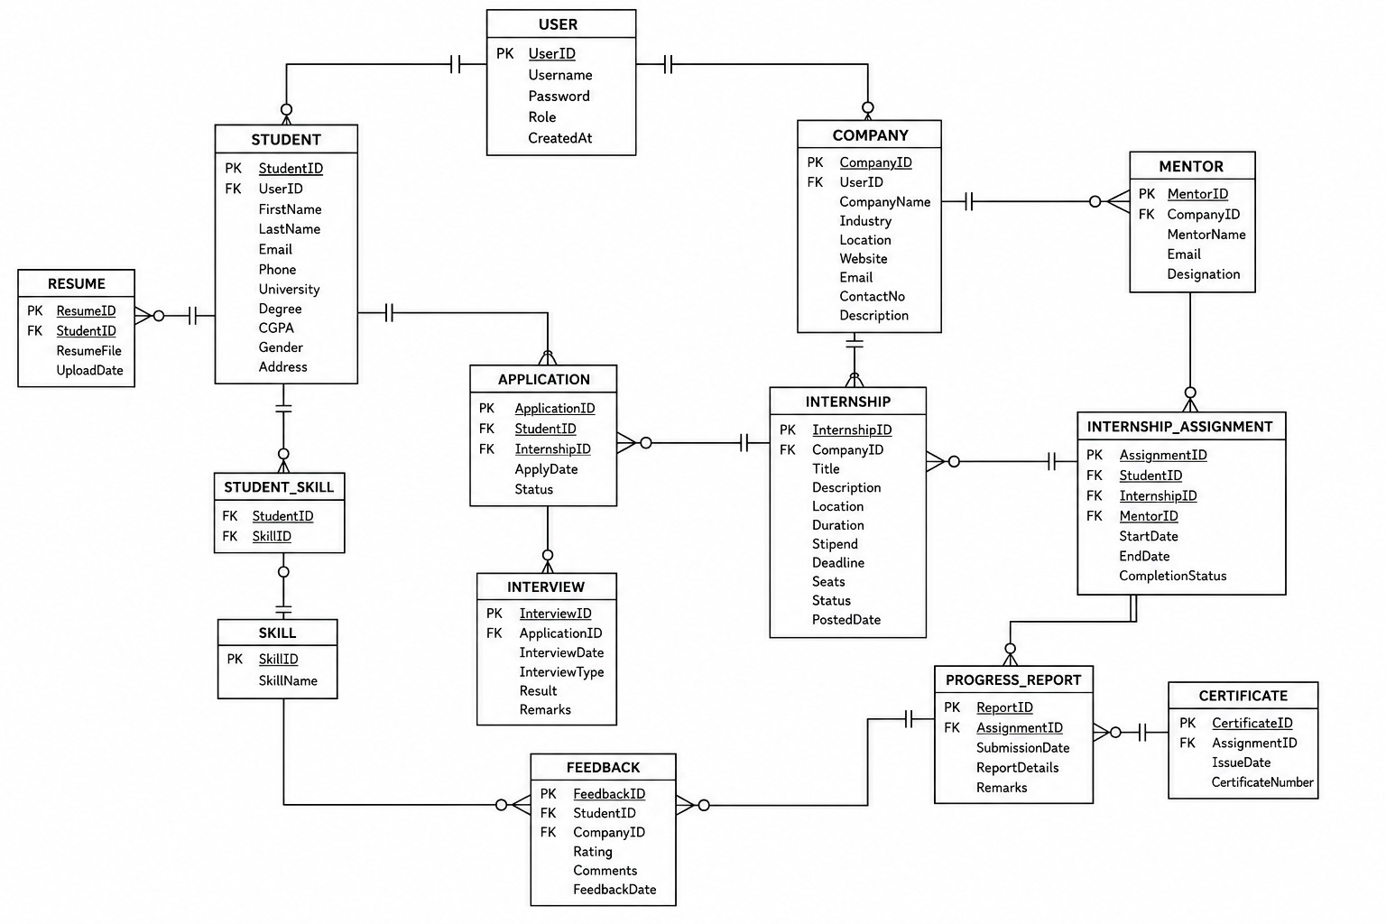
Entity Relationship Diagram of the Online Internship Management System

Entities Description
There are fourteen entities (tables) in this database. Each one is described briefly below:

1. USER
Stores the login information for every person using the system, whether they are a student or a company. It holds the username, password, and role (Student or Company), and acts as the base account for both Student and Company records.

2. STUDENT
Stores the personal and academic details of a student, such as name, email, phone, university, degree, and CGPA. Each student record is linked to one USER account.

3. COMPANY
Stores company details such as company name, industry, location, website, and contact information. Each company record is linked to one USER account.

4. MENTOR
Stores details of mentors who are assigned by companies to guide students during their internships, including mentor name, email, and designation.

5. RESUME
Stores the resume file uploaded by a student along with the upload date. Each student can upload one resume.

6. SKILL
Stores the master list of skills (such as Java, Communication, MS Excel) that can be associated with students.

7. STUDENT_SKILL
This is a linking table that connects students with their skills, since one student can have many skills and one skill can belong to many students.

8. INTERNSHIP
Stores details of internships posted by companies, such as title, description, location, duration, stipend, deadline, number of seats, and status.

9. APPLICATION
Stores the applications submitted by students for internships, including the date of application and the current status (such as Applied, Shortlisted, or Rejected).

10. INTERVIEW
Stores interview details related to a specific application, such as the interview date, type, result, and remarks.

11. INTERNSHIP_ASSIGNMENT
Stores the record of a student who has been selected and officially assigned to an internship, along with the assigned mentor, start date, end date, and completion status.

12. PROGRESS_REPORT
Stores periodic progress reports submitted during an internship assignment, including submission date and report details.

13. CERTIFICATE
Stores certificate details issued to a student after successful completion of an internship assignment, including the issue date and certificate number.

14. FEEDBACK
Stores feedback and rating given by a student about a company after the internship experience, including comments and feedback date.

Relationships Description
The tables in this database are connected through the following relationships:
- A USER can be linked to one STUDENT or one COMPANY profile (one-to-one), since each account belongs to either a student or a company.
- A STUDENT can have one RESUME (one-to-one).
- A STUDENT can have many SKILLS, and a SKILL can belong to many STUDENTS, connected through STUDENT_SKILL (many-to-many).
- A COMPANY can post many INTERNSHIPS (one-to-many).
- A COMPANY can have many MENTORS (one-to-many).
- A STUDENT can submit many APPLICATIONS, and an INTERNSHIP can receive many APPLICATIONS (many-to-many, resolved through the APPLICATION table).
- An APPLICATION can lead to many INTERVIEW records (one-to-many).
- A STUDENT, an INTERNSHIP, and a MENTOR are connected together through INTERNSHIP_ASSIGNMENT, which represents a confirmed placement (many-to-many-to-many resolved through one table).
- An INTERNSHIP_ASSIGNMENT can have many PROGRESS_REPORTS (one-to-many).
- An INTERNSHIP_ASSIGNMENT can result in one CERTIFICATE (one-to-one).
- A STUDENT can give many FEEDBACK records, and a COMPANY can receive many FEEDBACK records (many-to-many, resolved through the FEEDBACK table).

Cardinality and Participation Constraints
Cardinality defines how many instances of one entity can be related to instances of another entity. The table below summarizes the cardinality and participation of the main relationships shown in the ERD.
Relationship | Cardinality | Participation
USER — STUDENT | One to One | Partial on both sides
USER — COMPANY | One to One | Partial on both sides
STUDENT — RESUME | One to One | Partial (Resume optional)
STUDENT — STUDENT_SKILL | One to Many | Partial
SKILL — STUDENT_SKILL | One to Many | Partial
COMPANY — INTERNSHIP | One to Many | Partial
COMPANY — MENTOR | One to Many | Partial
STUDENT — APPLICATION | One to Many | Partial
INTERNSHIP — APPLICATION | One to Many | Partial
APPLICATION — INTERVIEW | One to Many | Partial
STUDENT — INTERNSHIP_ASSIGNMENT | One to Many | Partial
INTERNSHIP — INTERNSHIP_ASSIGNMENT | One to Many | Partial
MENTOR — INTERNSHIP_ASSIGNMENT | One to Many | Partial
INTERNSHIP_ASSIGNMENT — PROGRESS_REPORT | One to Many | Partial
INTERNSHIP_ASSIGNMENT — CERTIFICATE | One to One | Partial
STUDENT — FEEDBACK | One to Many | Partial
COMPANY — FEEDBACK | One to Many | Partial

Data Dictionary:
Table Name | Attributes
USER | UserID (PK), Username, Password, Role, CreatedAt
STUDENT | StudentID (PK), UserID (FK), FirstName, LastName, Email, Phone, University, Degree, CGPA, Gender, Address
COMPANY | CompanyID (PK), UserID (FK), CompanyName, Industry, Location, Website, Email, ContactNo, Description
MENTOR | MentorID (PK), CompanyID (FK), MentorName, Email, Designation
RESUME | ResumeID (PK), StudentID (FK), ResumeFile, UploadDate
SKILL | SkillID (PK), SkillName
STUDENT_SKILL | StudentID (FK), SkillID (FK)
INTERNSHIP | InternshipID (PK), CompanyID (FK), Title, Description, Location, Duration, Stipend, Deadline, Seats, Status, PostedDate
APPLICATION | ApplicationID (PK), StudentID (FK), InternshipID (FK), ApplyDate, Status
INTERVIEW | InterviewID (PK), ApplicationID (FK), InterviewDate, InterviewType, Result, Remarks
INTERNSHIP_ASSIGNMENT | AssignmentID (PK), StudentID (FK), InternshipID (FK), MentorID (FK), StartDate, EndDate, CompletionStatus
PROGRESS_REPORT | ReportID (PK), AssignmentID (FK), SubmissionDate, ReportDetails, Remarks
CERTIFICATE | CertificateID (PK), AssignmentID (FK), IssueDate, CertificateNumber
FEEDBACK | FeedbackID (PK), StudentID (FK), CompanyID (FK), Rating, Comments, FeedbackDate

